TimeCoins: A Digital Currency Backed by Shares
A PROJECT REPORT
for
Major Project-1 (CA301P)
Session (2025-26)

Submitted by

AMAN KUMAR 202410116100020
DEEPU KUMARI 202410116100057
ANAND PATEL 202410116100023

Submitted in partial fulfilment of the
Requirements for the Degree of

MASTER OF COMPUTER APPLICATION

Under the Supervision of
Ms. Hunny Gaur

Assistant Professor



Submitted to
Department Of Computer Applications
KIET Group of Institutions, Ghaziabad
Uttar Pradesh-201206

(November- 2025)

CERTIFICATE

Certified that Aman Kumar 202410116100020, Deepu Kumari 202410116100057, Anand Patel 202410116100023 has/ have carried out the project work having “TimeCoins: A Digital Currency Backed by Shares” (Major Project-I, CA301P) for Master of Computer Application from Dr. A.P.J. Abdul Kalam Technical University (AKTU) (formerly UPTU), Lucknow under my supervision. The project report embodies original work, and studies are carried out by the student himself/herself and the contents of the project report do not form the basis for the award of any other degree to the candidate or to anybody else from this or any other University/Institution.

Ms. Hunny Gaur Dr. Sachin Malhotra
Assistant Professor Dean
Department of Computer Applications Department of Computer Applications
KIET Group of Institutions, Ghaziabad KIET Group of Institutions, Ghaziabad

TimeCoins: A Digital Currency Backed by Shares
AMAN KUMAR, DEEPU KUMARI, ANAND PATEL

ABSTRACT

The rapid evolution of digital financial systems has led to the development of innovative currency models that integrate real-world market value with secure online transactions. TimeCoins is a share-backed digital currency designed to provide transparent, secure, and scalable financial interactions. In this system, the value of TimeCoins is directly influenced by the share market, ensuring real asset-based valuation rather than speculative inflation.
A unique feature of TimeCoins is its community-driven coin generation model. When a new company proposes investment by offering a percentage of its shares, it is listed on the platform for user voting. Based on user approval and analytical evaluation, the company may be accepted, enabling the generation of new TimeCoins proportional to the contributed share value. This approach promotes user participation, fair decision-making, and responsible currency growth.
To support seamless user communication, the system includes a hybrid real-time chat module, where messages are sent via HTTP requests and delivered to recipients instantly using WebSocket technology. The platform is developed using Spring Boot for the backend, React with Vite for the frontend, and MySQL for data storage. JWT-based authentication is implemented to ensure secure access and protect financial operations.
Overall, TimeCoins integrates secure transactions, real-time interaction, and community governance to build a modern digital currency ecosystem backed by trusted financial assets.
Keywords: Digital Currency, Share-Backed Asset, Community-Driven Coin Generation, Secure Transactions.

ACKNOWLEDGEMENTS

Success in life is never attained single-handedly. My deepest gratitude goes to my project supervisor, Ms. Hunny Gaur for her guidance, help, and encouragement throughout my project work. Their enlightening ideas, comments, and suggestions.
Words are not enough to express my gratitude to Dr. Sachin Malhotra, Professor and Dean, Department of Computer Applications, for his insightful comments and administrative help on various occasions.
Fortunately, I have many understanding friends, who have helped me a lot on many critical conditions.
Finally, my sincere thanks go to my family members and all those who have directly and indirectly provided me with moral support and other kind of help. Without their support, completion of this work would not have been possible in time. They keep my life filled with enjoyment and happiness.

AMAN KUMAR
DEEPU KUMARI
ANAND PATEL

Table of Contents
Assistant Professor i
CERTIFICATE ii
ABSTRACT iii
ACKNOWLEDGEMENTS iv
INTRODUCTION 6
1.1 OVERVIEW 6
1.2 SYSTEM OBJECTIVES 6
1.3 FUNCTIONALITY 6
1.4 SIGNIFICANCE 7
1.5 DATA COMMUNICATION 7
1.6 BASIC COMMUNICATION MODEL 7
1.7 REPORT STRUCTURE 8
Feasibility Study 9
2.1 Technical Feasibility 9
2.2 Operational Feasibility 9
2.3 Economic Feasibility 10
Literature Review 11
3.1 Digital Currency Systems 11
3.2. Share-Backed Financial Models 11
3.3. Community-Driven Governance Models 11
3.4. Real-Time Communication Technologies 12
3.5. Secure Authentication and Data Management 12
Project Objective 13
Hardware and Software Requirements 14
5.1 Hardware Requirements 14
5.2 Software Requirements 14
Project Flow 16
6.1 Requirement Gathering and Analysis 16
6.2 System Design 16
6.3 Technology Selection 16
6.4 Development 16
6.5 Deployment 17
6.7 Maintenance and Support 17
6.8 Future Enhancements 17
6.9 Use Case Diagram 17
6.10 Sequence Diagram 19
Project Outcome 20
References 21

CHAPTER 1

INTRODUCTION

1.1 OVERVIEW

In today’s digital era, the financial sector is rapidly adopting technology-driven solutions to enhance the security, transparency, and efficiency of transactions. Digital currencies have emerged as a powerful alternative to traditional financial systems. TimeCoins is a share-backed digital currency designed to link virtual currency value with real-world share market assets. The platform enables secure financial transactions, real-time communication, and user-driven currency expansion. By integrating voting-based approval of new share investments, TimeCoins introduces a democratic and trustworthy model for new coin generation.

1.2 SYSTEM OBJECTIVES
The major objectives of the TimeCoins system are:
- To create a digital asset whose value is derived from actual market-backed shares.
- To implement a community governance model for approving new investments.
- To provide secure and authenticated user access using JWT authentication.
- To enable real-time messaging and transaction updates through WebSocket technology.
- To maintain transparency in coin distribution and share contribution.
- To build a scalable and user-friendly financial interaction platform.

1.3 FUNCTIONALITY
TimeCoins offers the following key functionalities:
- Share-based Coin Generation: Approval of new companies through user voting followed by coin creation based on contributed share value.
- Secure User Authentication using JWT for login and financial operations.
- Real-time Chat System using hybrid messaging (HTTP + WebSocket).
- Transaction Management including sending, receiving, and storing transaction history.
- Email Notification System for voting participation and updates.
- User Dashboard for accessing wallet, voting panel, and communication features.

1.4 SIGNIFICANCE
TimeCoins provides a practical innovation in digital finance through:
- Economic Stability: Coin value depends on real share market performance.
- User Trust & Transparency: Community voting ensures fair decision-making.
- Increased Security: JWT access control and verified transactions protect users.
- Open Communication: Real-time messaging improves engagement within the ecosystem.
- Future Scalability: New companies and users can join, increasing market strength.

1.5 DATA COMMUNICATION
Communication in TimeCoins occurs in two forms:
- HTTP REST API for sending user requests such as login, voting, and chat message creation.
- WebSocket Channel for delivering live updates such as instant message notifications and transaction status.
This hybrid model ensures both data reliability and real-time interaction.

1.6 BASIC COMMUNICATION MODEL
The system employs a client-server communication model. Users (clients) access the platform through a web application built with React and Vite. The backend server built with Spring Boot handles business logic, authentication, messaging, coin generation, and database operations. MySQL stores persistent data, while WebSockets provide continuous two-way communication for instant event delivery. This model supports high responsiveness and secure data exchange.
MySQL databases store and retrieve user data securely and efficiently.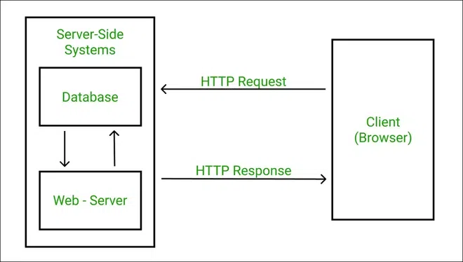
Figure 1.1 Database Architecture

1.7 REPORT STRUCTURE
This report is arranged into the following chapters:
- Introduction – Overview, significance, objectives, and communication model.
- Literature Review – Study of existing digital currency systems and related technologies.
- System Analysis – Requirements, existing vs. proposed system comparison.
- System Design – Architecture, database schema, module diagrams, and workflows.
- Implementation – Technologies used, coding strategies, and module development.
- Testing – Test cases, results, and validation of system performance.
- Conclusion and Future Scope – Achievements, limitations, and potential enhancements.
CHAPTER 2

Feasibility Study

2 Feasibility Study
A feasibility study is conducted to evaluate whether the proposed system is practical, technically valid, and economically beneficial. For the TimeCoins project, three major feasibility factors are analyzed: Technical, Operational, and Economic feasibility.

2.1 Technical Feasibility
The TimeCoins platform is developed using established and widely supported technologies including Spring Boot, React with Vite, and MySQL. These technologies provide:
- Strong Backend Performance through Spring Boot framework with secure and scalable APIs.
- Efficient Frontend Development using React (Vite) for faster UI rendering and modular components.
- Real-Time Communication via WebSocket for hybrid messaging and live notifications.
- Secure Authentication using JWT for controlled access and protection against unauthorized activities.
- Reliable Data Management using MySQL relational database for structured data storage.

All required tools, frameworks, and hardware resources are easily available, ensuring seamless development and deployment. Therefore, the project is technically feasible.

2.2 Operational Feasibility
The system is designed to offer an intuitive and user-friendly interface, ensuring that users can easily:
- Register and authenticate securely.
- Perform TimeCoin transactions.
- Vote for company approvals.
- Access wallet, balance history, and notifications.
- Communicate via live chat in real time.

Administrators can efficiently manage company proposals, analyze voting results, and oversee user activities. The strong integration of notifications and real-time updates enhances user engagement and reliability. Proper training and documentation make the system simple to operate. Thus, TimeCoins is operationally feasible.

2.3 Economic Feasibility
TimeCoins utilizes:
- Open-source technologies → no high-cost licensing
- Standard hardware and networking infrastructure
- Scalable architecture to reduce future cost overhead
The system can potentially generate revenue in the future through:
- Transaction/service fees
- Partnerships with approved companies
- Increased market adoption of TimeCoins

The long-term benefits exceed the initial development and maintenance expenses. Therefore, the project is economically feasible and capable of providing profitable outcomes.

CHAPTER 3

Literature Review

3. Literature Review
The increasing popularity of digital currencies and real-time financial communication systems has motivated researchers and organizations to innovate secure and value-driven digital ecosystems. This chapter reviews the existing technologies, models, and systems that have influenced the development of TimeCoins.

3.1 Digital Currency Systems
Digital currencies such as Bitcoin and Ethereum operate on decentralized blockchain technology. Their market value is primarily driven by speculation and demand, with no direct link to real-world assets. Although secure and transparent, such currencies experience high volatility, making them less suitable for stable financial transactions.

TimeCoins improves this concept by backing currency value with actual company shares, providing a more reliable and economically grounded valuation model.

3.2. Share-Backed Financial Models
Traditional stock markets allow users to invest in company shares, but these systems are:
- Often complex for general users
- Centralized and fully controlled by governing bodies
- Slow in transaction processing
TimeCoins combines digital currency flexibility with share market backing, offering:
- A democratic decision-making process through user voting
- A straightforward method for investment-driven coin creation
- Better transparency and public participation in financial growth

3.3. Community-Driven Governance Models
Some platforms enable Decentralized Autonomous Organizations (DAOs) where users vote on decisions related to currency or platform growth. However, most DAOs focus only on policy control rather than asset-backed coin generation.
TimeCoins leverages community approval as a core mechanism to expand currency supply responsibly.

3.4. Real-Time Communication Technologies
Modern applications use WebSocket technology for:
- Instant updates
- Live messaging
- Faster event-driven data exchange
Hybrid communication systems combining HTTP REST APIs with WebSockets are widely used in platforms such as social networks, gaming systems, and trading apps.

TimeCoins adopts this model to support:
- Real-time messaging
- Instant transaction status updates
- Notification delivery during voting phases

3.5. Secure Authentication and Data Management
JWT (JSON Web Token) is widely used for:
- Access control
- Session management
- Protecting sensitive operations
MySQL provides a reliable and structured approach to financial and user data storage.
Together, these technologies ensure that TimeCoins maintains:
- Strong security layers
- Data integrity
- Efficient backend performance

CHAPTER 4

Project Objective

The primary objective of the TimeCoins system is to create a secure, transparent, and innovative digital currency ecosystem backed by real-world share market assets. TimeCoins aims to connect digital financial models with community decision-making and real-time communication, offering users a stable and highly interactive economic platform.

The key objectives of the project are as follows:
- To develop a digital currency backed by company shares
- Ensuring real asset-based valuation for financial stability.
- To introduce a user-governed coin generation mechanism
- Allowing users to vote on company proposals before coin creation.
- To support secure and authenticated financial operations
- Using JWT-based authorization for login and all sensitive actions.
- To provide a real-time communication system between users
- Through hybrid messaging using HTTP and WebSocket technology.
- To enhance transparency in digital economic growth
- Showing how share contributions influence coin supply and value.
- To enable future e-commerce integration
- Allowing users to purchase products using TimeCoins, indirectly paying through share value.
- To improve user engagement in financial decision-making
- Notifications and voting participation improve trust and activity.
- To build a scalable and secure digital finance platform
- Capable of supporting a growing number of users and company partnerships.

Long-Term Vision
- To establish TimeCoins as a next-generation asset-based payment system
- To revolutionize online shopping by allowing share-backed purchases
- To promote fair and community-driven economic expansion

CHAPTER 5

Hardware and Software Requirements
A robust and efficient system design requires suitable hardware and software resources to ensure smooth development, deployment, and execution. TimeCoins uses modern development tools and efficient communication technologies to provide scalability, security, and high availability.

5.1 Hardware Requirements
The minimum hardware configuration required for development and execution is as follows:
Component | Requirement
Processor | Intel Core i3 or higher
RAM | 8 GB (minimum), 16 GB recommended
Hard Disk | Minimum 256 GB storage
Display | 1024 × 768 resolution or higher
Network | Stable broadband connection for real-time data exchange

For server deployment, higher hardware capabilities may be required based on the number of active users.

5.2 Software Requirements

Category | Software Used | Purpose
Operating System | Windows / Linux / macOS | Development and deployment environment
Backend Framework | Spring Boot | API development & business logic
Frontend Framework | React + Vite | UI development and fast build system
Database | MySQL | Structured data storage
Authentication | JWT (JSON Web Token) | Secure login and access control
Real-Time Technology | WebSocket | Hybrid messaging system
Programming Language | Java (Backend), JavaScript (Frontend) | Core development languages
Build Tools | Maven, npm | Dependency management
IDE/Editors | IntelliJ IDEA / Eclipse / VS Code | Code development tools
Version Control | Git, GitHub | Code collaboration & repository management
Email Service | SMTP Mail Server | Voting and notification alerts

Additional Tools and Libraries
- Redux Toolkit → Global state management in frontend
- Axios → API communication
- Spring Security → Authentication and authorization
- Node.js → Frontend package management and builds
- WebSocket Client Libraries → Real-time communication support

CHAPTER 6

Project Flow

6.1 Requirement Gathering and Analysis
  - Identified the primary functional requirements such as user registration, login, wallet creation, TimeCoins transfer, transaction history, and product purchasing via TimeCoins.
  - Studied security requirements including password encryption, role-based authentication, and secure transactions.
  - Understood business rules: limited supply of TimeCoins, share-based valuation, and demand-driven price fluctuations.
  - Prepared SRS (Software Requirement Specification) to finalize application scope.

6.2 System Design
Designed the system architecture following a secure and scalable layered structure:
- Presentation Layer → UI handling user interactions
- Business Layer → Controller & Service handling logic
- Data Layer → Repository & Database storage
Focus on modular design for easier enhancements, wallet APIs, messaging services, and integrations.

6.3 Technology Selection
- Backend: Spring Boot (Java), REST API
- Frontend: React with VITE
- Database: MySQL
- Security: Spring Security + JWT Authentication
- Others: WebSocket (Real-time transactions & messages)
Reason for selection:
High scalability, enterprise-level security, efficient communication between components, and strong community support.

6.4 Development
- Implemented REST APIs for complete wallet lifecycle:
- User Registration, Login, Logout
- Wallet Initialization
- Secure Payment Authorization
- Transaction History Logging (Success & Failure)
- Introduced Business Rules:
- TimeCoins mapped to company share value
- Value updated dynamically based on demand
- Implemented WebSocket notifications for real-time transaction status.
- Validations added for incorrect password, insufficient balance, and unauthorized access.

6.5 Deployment
- Application packaged using Maven build.
- Deployed on cloud environment / local server using:
- Apache Tomcat
- MySQL Cloud/Local Database
- Continuous testing & monitoring enabled before production release.

6.7 Maintenance and Support
- Continuous monitoring of API performance and security vulnerabilities.
- Bug fixes and updates based on user feedback.
- Backup mechanisms and logs maintained for all financial actions.

6.8 Future Enhancements
- Integration with major e-commerce companies (Like Flipkart/Amazon - users buy products using TimeCoins which represent indirect shares).
- Mobile application version for Android & iOS.
- AI-powered fraud detection.
- TimeCoins trading marketplace where users buy/sell TimeCoins openly.

6.9 Use Case Diagram
A use case diagram is used to represent the dynamic behavior of a system. It encapsulates the system's functionality by incorporating use cases, actors, and their relationships. It models the tasks, services, and functions required by a system/subsystem of an application. It depicts the high-level functionality of a system and also tells how the user handles a system. Following are the purposes of a use case diagram given below:
- It gathers the system's needs.
- It depicts the external view of the system.
- It recognizes the internal as well as external factors that influence the system.
- It represents the interaction between the actors.

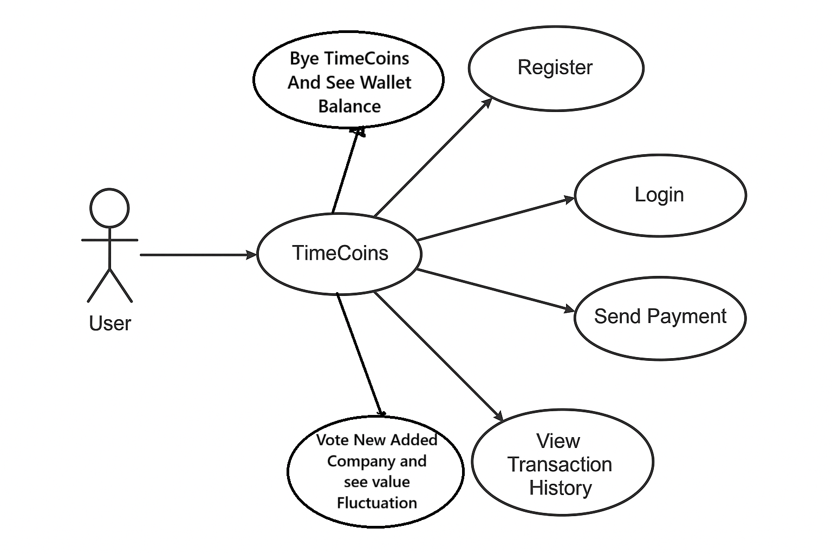
Figure 6.3 Use Case Diagram

6.10 Sequence Diagram
The sequence diagram represents the flow of messages in the system and is also termed as an event diagram. It helps in envisioning several dynamic scenarios. It portrays the communication between any two lifelines as a time-ordered sequence of events, such that these lifelines took part at the run time. In UML, the lifeline is represented by a vertical bar, whereas the message flow is represented by a vertical dotted line that extends across the bottom of the page. It incorporates the iterations as well as branching.
Purpose of a Sequence Diagram
To model high-level interaction among active objects within a system.
To model interaction among objects inside a collaboration realizing a use case.
It either models’ generic interactions or some certain instances of interaction.

Figure 6.4 Sequence Diagram

CHAPTER 7

Project Outcome

References

